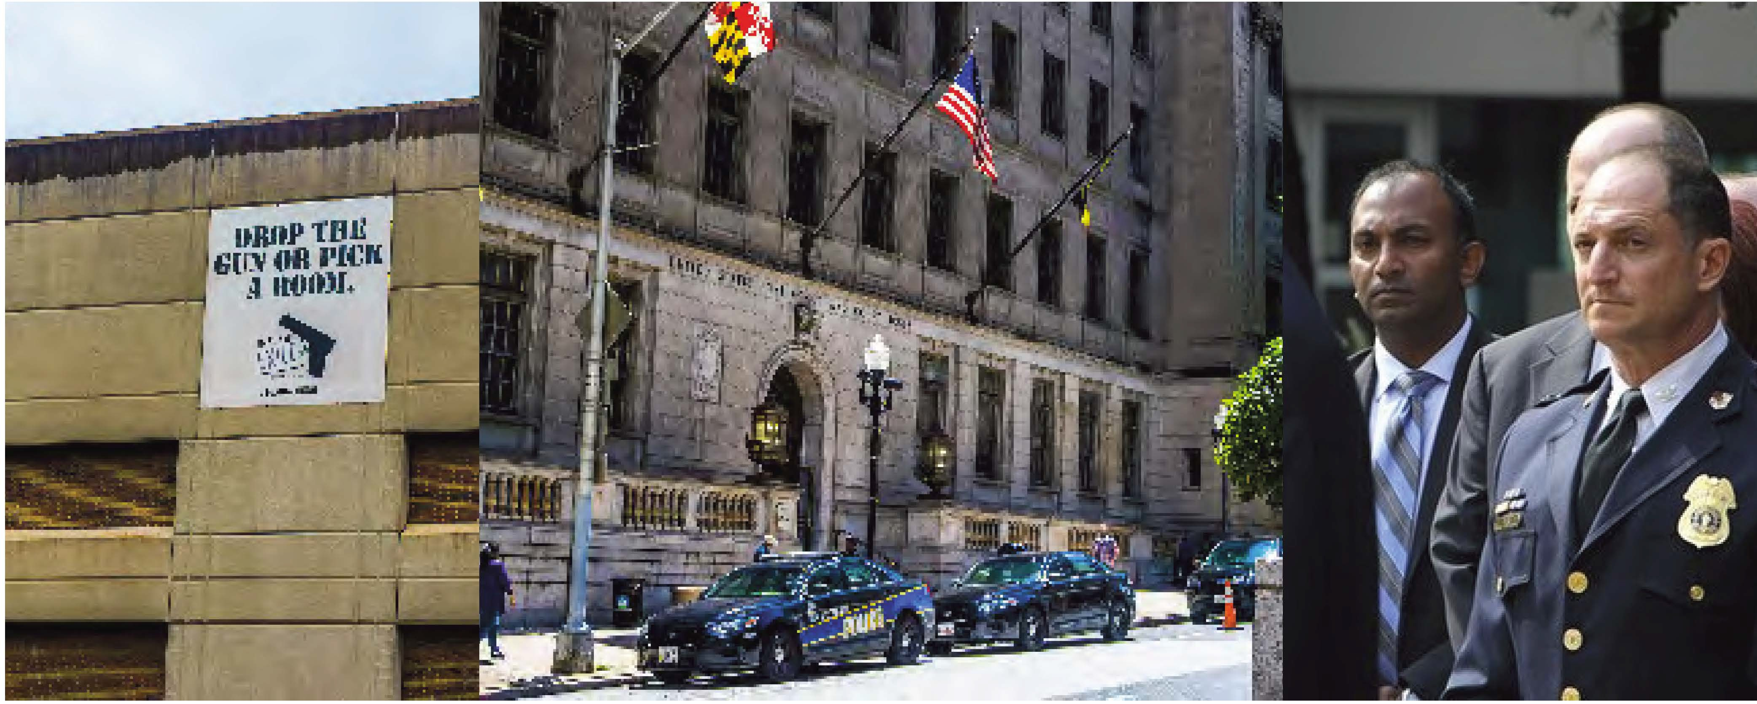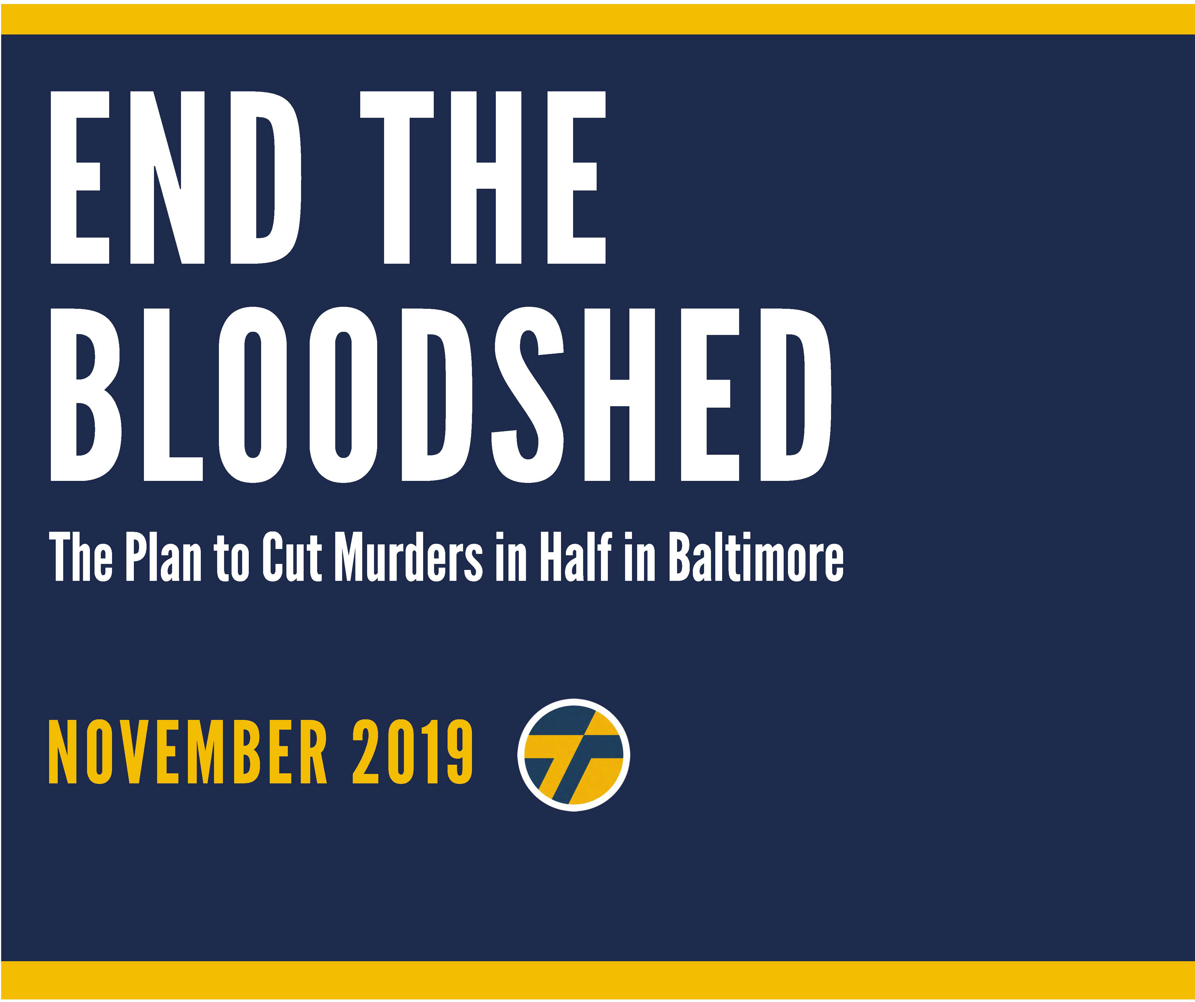





Thiru’s “End the Bloodshed” plan sets forth a comprehensive strategy that goes beyond the platitudes and empty prescriptions that have been recycled and repackaged for decades. Enough is enough.

End the Bloodshed certainly adopts and incorporates important components of prior plans around which there is clear consensus — from investments in schools, jobs, and youth initiatives, to better strategies to address trauma and mental health, to dismantling institutional racism. However, Thiru’s plan, focused on solutions, presents 20 unique proposals that are specific, actionable, and unprecedented.

Conduct Simultaneous Wiretap Investigations

For the first time, Baltimore will conduct simultaneous wiretap investigations targeting gangs and drug organizations in the city’s 12 deadliest neighborhoods, culminating in coordinated arrests of 150-250 violent criminals around April 2025, just before the annual summer surge of gun violence. (The arrest of a couple hundred defendants pales in comparison to the tens of thousands arrested every year in Baltimore.)

Automatic Review of the U.S. Attorney's Office

For the first time, Baltimore will refer to the U.S. Attorney’s Office for automatic review all carjackings, bank and commercial robberies, and felon-in-possession cases for potential federal prosecution. (These are categories of crimes over which there is federal jurisdiction.)

Aerial Surveillance Program

For the first time, Baltimore will get off the ground—with public disclosure—the aerial surveillance program to aid detectives with violent crime investigations, this time with specific limits to respect community privacy and confirm the program’s legal validity.

Additional Ground Cameras

For the first time, Baltimore will offer $100 rebates to residential and commercial property owners who purchase cloud- based security cameras and register them with BPD, with the ultimate goal of adding 10,000 ground cameras to the city’s private camera network.

Clear the Backlog of Burglary Evidence

For the first time, Baltimore will use private grant funding to clear the backlog of untested burglary crime scene evidence, which will be used to pursue burglary prosecutions against individuals who have committed robberies, carjackings, shootings, and murders, but have escaped prosecution for these more serious violent crimes.

Launch Cold Case Initiative

For the first time, Baltimore will launch a cold case initiative within City Hall, which will coordinate with BPD, as well as other law enforcement agencies, to keep open or reopen murder investigations involving high-caliber weaponry, 10 or more casings, and headshots.

Anonymous Monitoring of Juvenile Cases

For the first time, Baltimore will facilitate anonymized monitoring of juvenile cases, so the public can better track outcomes in violent crime cases involving juvenile offenders.

Non-Public Repeat Juvenile Offender List

For the first time, Baltimore will prepare a non-public list of repeat violent juvenile offenders and develop customized strategies to ensure they are brought to justice.

Create a Deputy Mayor for Public Safety

For the first time, Baltimore will create a Deputy Mayor for Public Safety who will ensure inter-agency cooperation to support BPD fully in the fight against crime, a post that will be filled by a respected crime fighter.





For the first time, Baltimore will form the Office of the Public Advocate, which will ensure that policing satisfies

community expectations and constitutional standards, a post that will be filled by a respected community activist and civil rights leader.

Dedicate $10 Million to a Diversion Program

For the first time, Baltimore will dedicate $10 million to a diversion program that permits qualifying juvenile offenders and adults charged with low-level offenses to avoid prison by agreeing, as a condition of probation, to enroll in skills training, workforce development, and a job placement program.

Forgive Outstanding Debt Owed to the Government

For the first time, Baltimore will forgive outstanding debt owed to the government by returning citizens if they maintain stable employment and avoid criminal conduct for 2 years.

Faith in Justice Reentry Initiative

For the first time, Baltimore will launch its “Faith in Justice” reentry initiative, securing $5,000,000 in federal grant money

from the Second Chance Act, which is dispersed to 100 nonprofits and faith organizations selected by 500 returning citizens to support their reentry.

College Cadet Program

For the first time, Baltimore will create a College Cadet program to recruit 100-150 graduating seniors each year from local universities, particularly HBCUs like Morgan State and Coppin State, in order to rapidly produce a net gain of 600 officers and forge a more diverse, local, and professional police force.

Lifting Arbitrary Police Eligibility Restrictions

For the first time, Baltimore will drive BPD recruitment by lifting arbitrary police eligibility restrictions, including the ban on permanent resident non-citizens and people who have used marijuana in the last three years.

Redeploy 90+ School Resource Officers

For the first time, Baltimore will redeploy 90+ school resource officers (SROs) from their posts inside public schools to perform much-needed foot patrols in the neighborhoods around their schools, instead of fueling the school-to-prison pipeline.

Hiring Private Security in Limited, Site-Specific Contexts

For the first time, Baltimore will free up detectives to return to doing detective work by hiring private security in limited, site- specific contexts to ensure adequate coverage of business districts and public events.

Instituting Automatic Audits of Over Time

For the first time, Baltimore will deter police corruption by instituting automatic audits of overtime where an officer has claimed more than $10,000 in overtime compensation.

Annual Reports of Public Health Indicators that Drive Violence

For the first time, Baltimore will publish an annual report of public health indicators that drive violence to ensure that the work of all agencies is evaluated in the fight against crime.

Open ComStat to the Press and Public

For the first time, Baltimore will once a month open ComStat to press and the public in order to promote police accountability and greater transparency.

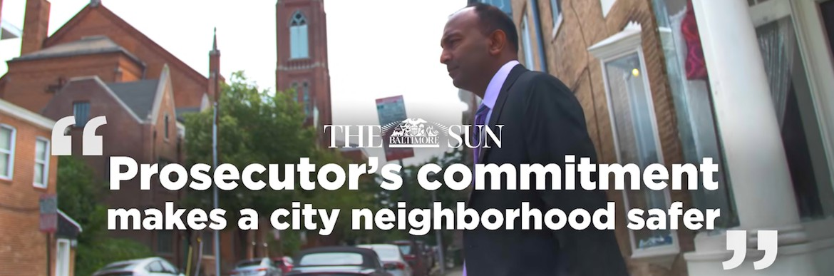

**EXECUTIVE SUMMARY**

Violent crime is the dominant, defining challenge facing Baltimore. It ravages neighborhoods, drives families out of the city, deters business investment, and destroys the lives of too many of Baltimore’s sons and daughters. The next Mayor’s top focus must be to end the bloodshed.

Thiru’s “End the Bloodshed” plan sets forth a comprehensive, detailed, and actionable strategy that goes beyond the platitudes and empty prescriptions that have been recycled and repackaged for decades. It accounts for the current deficit in police officers and the constraints of the federal consent decree; it builds on the crime reduction plans set forth by others, including that of Commissioner Michael Harrison, which is understandably focused on changing culture, rebuilding basic department infrastructure, and improving patrol operations in high-crime areas; it reckons with the reality of prosecuting cases in Baltimore City where juries respond best to cases where police and eyewitness testimony is corroborated by forensic evidence and camera footage; it creates two new positions in City Hall and promises a monthly ComStat open to the public; it brings accountability and transparency principles featured in adult prosecutions to the juvenile justice system; it establishes and expands specific cost-effective diversion and reentry initiatives; and it takes seriously a citywide commitment to reconceive crime in Baltimore as a public health crisis in need of acute interventions as well as systemic solutions.

It accomplishes all of this while pledging a leaner police budget, prescribing a timetable for action, and presenting clear metrics of success.

Thiru and his team took note of the various crime plans that have been released over the years, all of which recite similar themes and typically lack the kind of detail the public needs to gauge whether a plan is viable. *End the Bloodshed* certainly adopts and incorporates important components of prior plans around which there is clear consensus: special focus on violent repeat offenders; investments in schools, jobs, and youth initiatives; rebuilding the Department’s information systems; better strategies to address trauma, addiction, and mental health; reconceiving crime as a public health crisis; strengthening families; dismantling systemic and institutional racism; reforming the criminal justice system; and expanding proven programs like ROCA, YouthWorks, Safe Streets, and LEAD.

These are vital parts of any sound crime plan and represent a common foundation on which most agree. On top of this, Thiru’s plan contains proposals that are specific, actionable, and unprecedented. The following are illustrations of 20 features unique to *End the Bloodshed*:

* For the first time, Baltimore will **conduct simultaneous wiretap investigations** targeting gangs and drug organizations in the city’s 12 deadliest neighborhoods, culminating in coordinated arrests of 150-250 violent criminals around April 2025, just before the annual summer surge of gun violence. (The arrest of a couple hundred defendants pales in comparison to the tens of thousands arrested every year in Baltimore.)
* For the first time, Baltimore will **refer to the U.S. Attorney’s Office for automatic review** all carjackings, bank and commercial robberies, and felon-in- possession cases for potential federal prosecution. (These are categories of crimes over which there is federal jurisdiction.)
* For the first time, Baltimore will get off the ground—with public disclosure— the **aerial surveillance program** to aid detectives with violent crime investigations, this time with specific limits to respect community privacy and confirm the program’s legal validity.
* For the first time, Baltimore will offer $100 rebates to residential and commercial property owners who purchase cloud-based security cameras and register them with BPD, with the ultimate goal of **adding 10,000 ground cameras** to the city’s private camera network.
* For the first time, Baltimore will use private grant funding to **clear the backlog of untested burglary crime scene evidence**, which will be used to pursue burglary prosecutions against individuals who have committed robberies, carjackings, shootings, and murders, but have escaped prosecution for these more serious violent crimes.
* For the first time, Baltimore will **launch a cold case initiative** within City Hall, which will coordinate with BPD, as well as other law enforcement agencies, to keep open or reopen murder investigations involving high-caliber weaponry, 10 or more casings, and headshots.
* For the first time, Baltimore will facilitate **anonymized monitoring of juvenile cases**, so the public can better track outcomes in violent crime cases involving juvenile offenders.
* For the first time, Baltimore will prepare a **non-public list of repeat violent juvenile offenders** and develop customized strategies to ensure they are brought to justice.
* For the first time, Baltimore will **create a Deputy Mayor for Public Safety** who will ensure interagency cooperation to support BPD fully in the fight against crime, a post that will be filled by a respected crime fighter.
* For the first time, Baltimore will **form the Office of the Public Advocate**, which will ensure that policing satisfies community expectations and constitutional standards, a post that will be filled by a respected community activist and civil rights leader.
* For the first time, Baltimore will **dedicate $10 million to a diversion program** that permits qualifying juvenile offenders and adults charged with low-level offenses to avoid prison by agreeing, as a condition of probation, to enroll in skills training, workforce development, and a job placement program. (The campaign unveiled this initiative—the “Court to Career” program—two weeks ago with the support of Ravens linebacker Matthew Judon.)
* For the first time, Baltimore will **forgive outstanding debt owed to the government** by returning citizens if they maintain stable employment and avoid criminal conduct for two years.
* For the first time, Baltimore will **launch its “Faith in Justice” reentry initiative**, securing $5,000,000 in federal grant money from the Second Chance Act, which is dispersed to 100 nonprofits and faith organizations selected by 500 returning citizens to support their reentry.
* For the first time, Baltimore will **create a College Cadet program** to recruit 100-150 graduating seniors each year from local universities, particularly HBCUs like Morgan State and Coppin State, in order to rapidly produce a net gain of 600 officers and forge a more diverse, local, and professional force.
* For the first time, Baltimore will drive BPD recruitment by **lifting arbitrary police eligibility restrictions**, including the ban on permanent resident non- citizens and people who have used marijuana in the last three years.
* For the first time, Baltimore will **redeploy 90+ school resource officers** (SROs) from their posts inside public schools to perform much-needed foot patrols in the neighborhoods around their schools, instead of fueling the school-to-prison pipeline.
* For the first time, Baltimore will free up detectives to return to doing detective work **by hiring private security in limited, site-specific contexts** to ensure adequate coverage of business districts and public events.
* For the first time, Baltimore will deter police corruption by **instituting automatic audits of overtime** where an officer has claimed more than $10,000 in overtime compensation.
* For the first time, Baltimore will publish an **annual report of public health indicators that drive violence** to ensure that the work of all agencies is evaluated in the fight against crime.
* For the first time, Baltimore will once a month **open ComStat to press and the public** in order to promote police accountability and greater transparency.

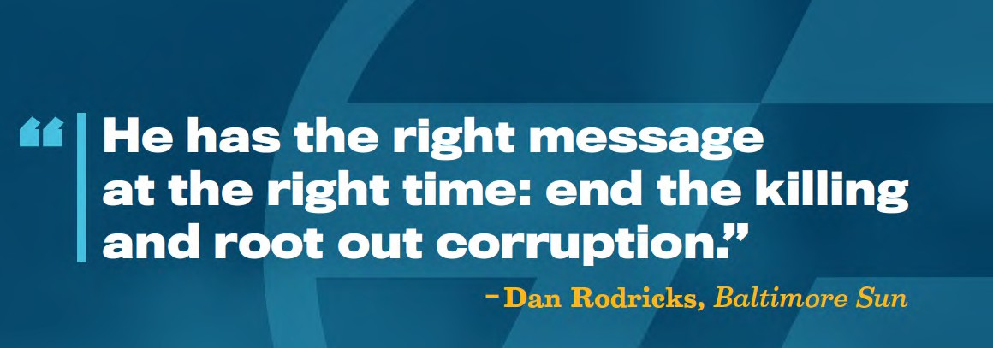

**Drive Down Citywide Murder Rate**

We know gun violence is driven by a small number of identifiable repeat offenders, typically members of gangs, who ravage essentially the same neighborhoods year after year. Because of this, **dramatically reducing gun violence does not require mass incarceration, zero tolerance, or cash bail.** What is needed is relentless focus on the deadliest neighborhoods, deadliest criminals, and deadliest crimes. City Hall has failed to deliver that focus and, as a result, has failed to deliver justice to countless Baltimore families.

As Mayor, Thiru will drive down the number of murders to below 200 within three years. This will not happen by accident. It will happen because city leaders will develop a battle plan and execute it. Here are the cornerstones of Thiru’s plan to end the bloodshed.

* Launch simultaneous wiretap investigations in the City’s 12 deadliest neighborhoods with coordinated arrests before the killing months of summer.

**Between 2015 and 2018, 26% of all murders occurred in 12 neighborhoods.** Because these consistently high murder rates are fueled by gangs feuding over consistently profitable drug territory, wiretap investigations are a potent, proven method of shutting down the violence.

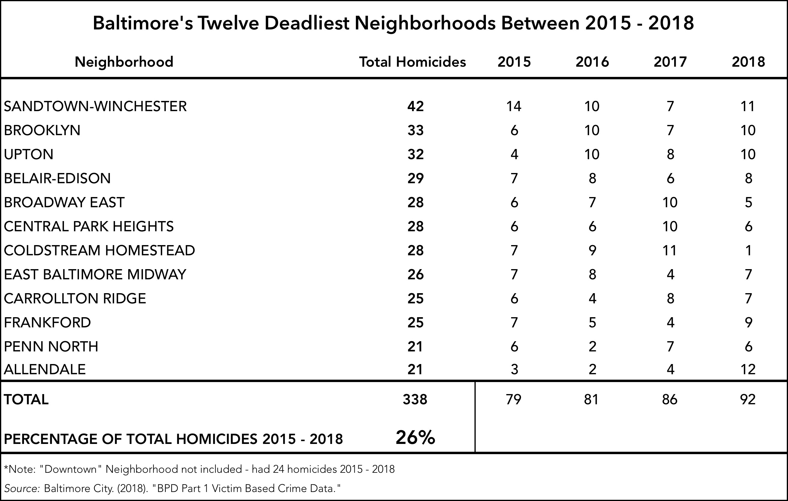

THIS DATA NEEDS TO BE UPDATED; AT THIS MOMENT DATA IS ONLY AVAILABLE FROM MAY 20th 2019 through all of 2020

These surgical investigations do not require police to clear corners or pursue the irresponsible stop-and-frisk policies that have characterized discriminatory approaches of the past. Instead, law enforcement should develop intelligence to identify the shooters, killers, and leaders in each of these 12 neighborhoods, launch wiretap investigations using undercovers and forensic technology, and after a thorough investigation, extract the violent organization, root and branch.

**We know this strategy can work.**

In November 2013, police and prosecutors, under Thiru’s leadership, brought a first- of-its-kind gang prosecution to a neighborhood that had endured nearly a murder or shooting every month for five years. For 18 months, that same neighborhood didn’t see a single murder. Not one. That strategy did not displace violence; it eliminated it.

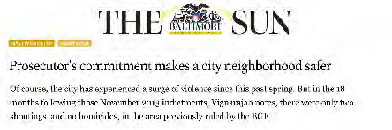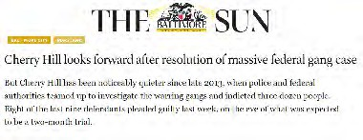

A similar strategy was deployed in Cherry Hill, where federal and local prosecutors conducted a collaborative gang investigation. Cherry Hill went some 700 days without a single shooting.

This was an anchor strategy that brought murders to below 200 just a few years ago. Even back then, the City tended to conduct these investigations one at a time, rather than simultaneously. And, for the past 5 years, this approach has been all but absent.

As Mayor, Thiru would convene local, state, and federal law enforcement partners, develop a tactical battleplan dividing responsibility among the FBI, DEA, ATF, MSP and BPD, and execute the intelligence gathering, undercover buys, wiretap investigation, and arrest phases of the operation in as coordinated a fashion as possible.

12 DEADLIEST NEIGHBORHOODS IN BALTIMORE

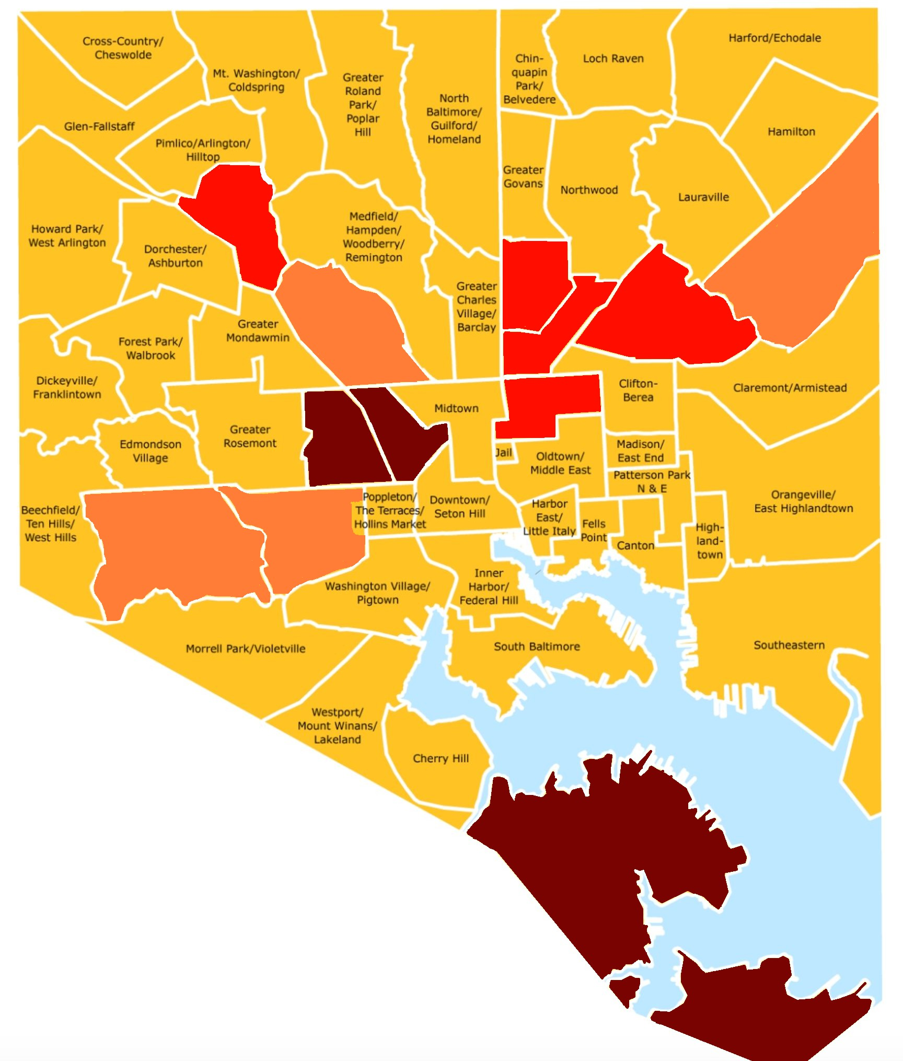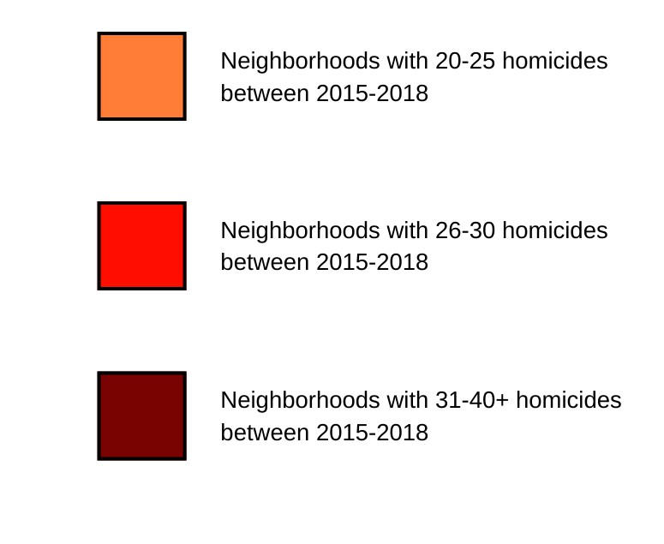

**Southern Park Heights**

**The Waverlies**

**Cedonia/Frakford**

**Penn North/ Reservoir Hill**

**Belair-Edison**

**Midway**

**Greenmount East**

**Upton**

**Sandtown- Winchester/ Harlem Park**

**Allendale/ Irvington/**

**S. Hilton**

**Southwest Baltimore**

**Brooklyn/ Curtis Bay/ Hawkins Point**

SOURCE? NEEDS UPDATE FROM SPECIFIC SOURCE

It is important to emphasize that these investigations do not require hundreds of officers nor do they end in thousands of arrests. In fact, these proactive investigations are best done with a small, experienced platoon of city officers and federal agents led by one or two federal and local prosecutors. The “End the Bloodshed” plan calls for intel workups to begin shortly after the Democratic primary (May 2024), the wiretap investigations to begin that winter (November-December 2024), with arrests just before the summer (April 2025). Rather than initiate a case or create a new initiative in response to a summer of violence, this strategy is designed to anticipate and prevent the violence just before, if history is a guide, it is set to surge.

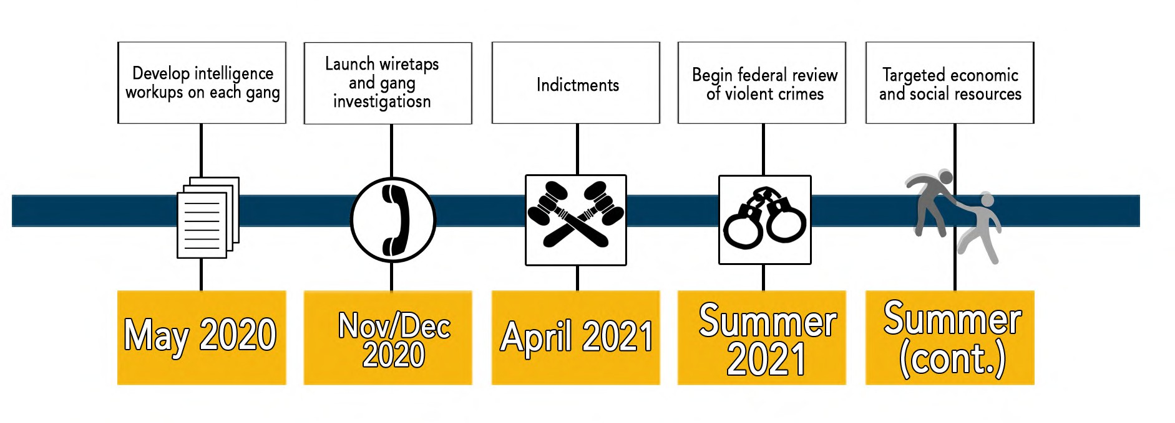

UPDATED FIGURE

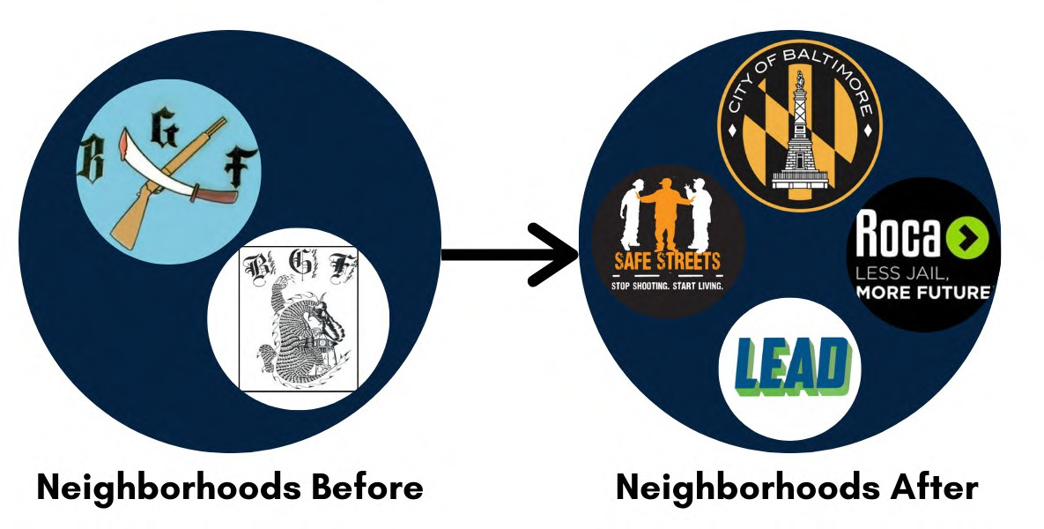The law enforcement intervention cannot be the end of the work in these neighborhoods. Rather than pushing the violence to neighboring areas, which is what traditional patrol-focused strategies tend to do, extracting the gang will bring about a period of real peace but it will also create a vacuum. New gangs and violent drug organizations cannot be allowed to fill the void. Rather, we must bring to bear a coordinated array of resources and support organizations from Safe Streets and Ceasefire (focused on the violence) to ROCA and LEAD (focused on addiction) to a bevy of operators devoted to expunging records, workforce and housing development, lead abatement, job placement, mental health, and trauma.

* Identify, investigate, and prosecute the worst violent offenders in each police district.

As Mayor, Thiru will also focus on identifying, investigating, and getting off the streets the worst violent repeat offenders in Baltimore. Each police district will use a combination of concrete metrics (prior convictions for violent crimes and gun offenses), along with on-the-ground intelligence to determine which criminals warrant greater investigative attention. A new Deputy Mayor for Public Safety will be responsible for coordinating interagency cooperation to ensure that responsible, rock solid cases are being built at local, state, and federal levels. BPD will be responsible for ensuring that resources are focused not on nuisance cases to drive public statistics, but rather on the individuals who are genuinely perpetrating violent crimes. This model of focused investigations mirrors the approach Thiru led when he was Chief of Major Investigations in Baltimore City. This initiative is all about execution and depends on strong leadership beginning with the Mayor and Deputy Mayor for Public Safety.

* Launch specialized Cold Case initiative to focus on solving high-lethality murders.

As Mayor, Thiru will create the “Never Forgotten” Cold Case initiative in City Hall, which will work with BPD, as well as MSP and other law enforcement agencies, to ensure that law enforcement maintains investigative focus on murders involving high-caliber guns, 10+ casings at the crime scene, and headshots. Families will also have a liaison in City Hall to provide any information

that can be shared about the status of an investigation that is more than a year old.

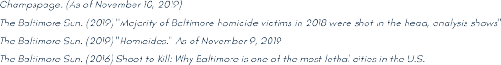

This is necessary because as clearance rates have plummeted, murders have soared, with five years of 300+ murders. So has the percentage of headshots, with a startling high of 57% of homicides last year involving fatal headwounds. Murderers in Baltimore have become the most lethal in America, with higher caliber weaponry, more shots per crime

FIGURE ON PAGE ABOVE

scene, and the highest percentage of headshots in the country. The individuals perpetrating these ruthless, calculating executions are rarely first-time offenders. They are seasoned executioners, and those homicides deserve special attention.

It should be noted that even the paltry clearance rates advertised by BPD today are somewhat misleading to the average citizen. Clearance rates are not the percentages of murders that result in an arrest, because the Department includes in the overall count of cleared cases what it calls “exceptional clearances,” a term of art that refers to an investigation that cannot lead to an arrest (most often because the supposed suspect has himself been killed). Exceptional clearances have soared recently, which means an increasingly small number of murders actually end in an arrest.

**“To deter murders, we have to solve and prosecute more murders. Not on paper. But in real life.**

**This plan helps do just that.”**

**Build a Police Force for the Next Century**

For years, the Baltimore Police Department (BPD) has been expected to effectively fight crime with a fraction of its full force. The Department once had as many as 3,300 officers. Before her resignation, Mayor Catherine Pugh estimated that BPD had 1,900 active officers, though it was authorized for 2,800 officers; this shortfall has crippled the City’s ability to fight crime and generated massive overruns in overtime expenditures. Because of poor recordkeeping, estimates vary how many recruits are needed, but most agree the Department is hundreds of officers short.

From 2002 through 2022, there was an overall loss of 1176 police officers, with 3,873 hires and 5,049 departures. The net loss from 2019 to 2022 alone is 329 officers. The loss of officers has not only made the city less safe, but has burdened taxpayers with soaring overtime costs. CHART NEEDS TO BE UPDATED

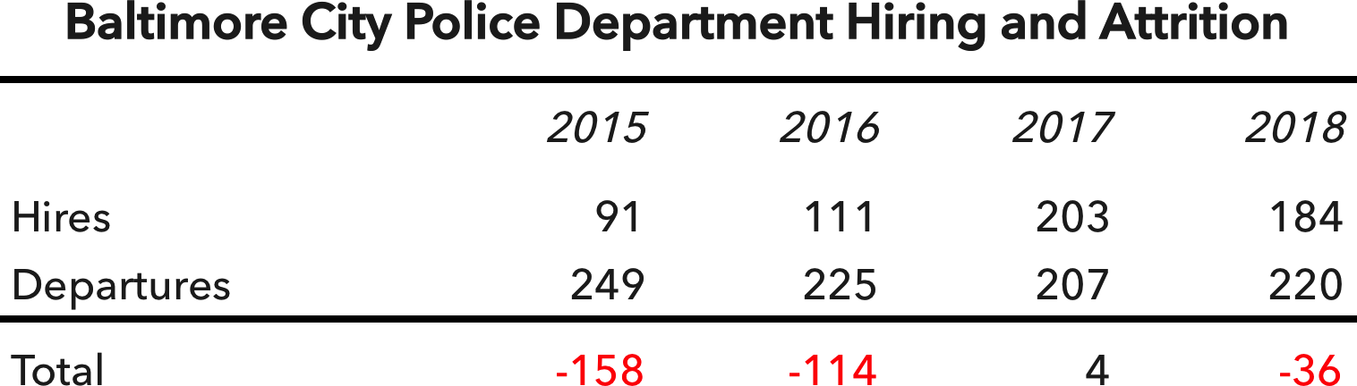

Estimates vary as to the exact magnitude of the shortfall. There are no less than hundreds of budgeted positions that sit empty, though some claim we need more than a thousand more officers. Precise number aside, the bottom line is that the police department needs more police.

This deficit in personnel should not be seen as a problem, but rather, as an opportunity. BPD has a chance to rebuild a police force that looks and acts like the Department Baltimore deserves. In this respect, reconstituting the police force is not just about bringing in more officers – it's about bringing in the right officers and keeping them here. It’s about training our officers to do the kind of effective, constitutional investigations that will restore community trust and get violent criminals out off the streets.

**As Mayor, Thiru will drive a net increase of 600 police officers who are more diverse, less costly, and more effective than ever.**

### RECRUIT, RETAIN, REVITALIZE



1. Launch college cadet program to grow a diverse, local police force
2. Forgive up to $25,000 in student loan debt for officers who live and serve in Baltimore for 5 years
3. Rebrand careers in law enforcement as opportunity for advancement and service
4. Provide bonuses for lateral transfers from other Maryland jurisdictions and returning servicemen and women
5. Lift arbitrary police eligibility requirements including the ban on permanent resident non-citizens and people who have used

marijuana in the last three years

1. Use housing incentives to encourage officers to live in Baltimore City and increase community policing
2. Institute rank of Corporal to promote advancement and accountability through supervision
3. Restore 20-year pension eligibility for officers subject to unjust, retroactive 25-year pension requirement

**RECRUIT | REDEPLOY | RETRAIN**

**Recruit.** We cannot wait decades for change. We must act now. Under Thiru’s plan, we will produce a net increase of 600 active-duty police officers. Baltimore will recruit hundreds more officers, redeploy police to reflect the community’s needs and priorities, and retrain officers who build stronger cases and better reflect constitutional policing in the next century. Police are not the sole answer to crime, but they have to be part of it. And the deficit of officers presents a rare chance to rebuild a Department that is more local, more professional, and more diverse, with more women, minorities, and immigrants.

As of 2022, only 16% of Baltimore’s police force was female; nor is the police force as racially diverse as it needs to be. And the Justice Department has reported that, “roughly three-fourths of Baltimore PD officers live outside the Baltimore City limits.” All of this must change. But change does not require strict rules or quotas. The Department must tailor its recruiting strategy to the types of officers it seeks to bring in, train, and keep.

We know a more diverse police force can drive lower crime and more just policing, and studies have shown that more women in a police department generates higher reporting of violent crimes against women including rape, domestic violence, and human trafficking. Here is where Thiru, as Mayor, will focus to recruit a new generation of police:

* + Recruit heavily from local colleges, particularly HBCUs, with school-year and summer internships, senior-year cadet programs, and an emphasis on building the kind of community-based police force we can all be proud of.

There is plenty of local talent at our local colleges and universities. In 2015, 567 graduates of Baltimore City high schools went off to attend 13 colleges in the Baltimore area. They are now seniors looking for a job, and many of them are Baltimore natives looking to come home. As Mayor, Thiru will implement a recruiting initiative that does for the policing in Baltimore what Teach for America did for teaching across the country. Instead of a cadet program that focuses solely on high school students who are several years away from being eligible to enroll as officers, an expanded cadet program would have a dozen openings at each local college and university for seniors who would be placed on the fast-track into the Department. Semester and summer internships even

earlier in college would expose students to the critical work police are doing in Baltimore and to the senior cadet initiative for college seniors.

By making local college students feel they are part of the solution when it comes to perceived problems with policing in America, we can set up clear pathways to well-paying positions with stable benefits and career advancement opportunities. This is a guaranteed renewable source of motivated young professionals who could quickly replenish the foundation of the Baltimore Police Department.

* + Remove recruitment impediments by lifting marijuana restrictions, prioritizing mental fitness assessments over physical fitness tests, and allowing immigrants to serve.

The department should focus more on psychological evaluations and reevaluate physical fitness tests, an outmoded hurdle that results in far fewer female officers. Also, neither permanent-resident immigrants nor anyone who has smoked marijuana in the last three years can currently apply to be a Baltimore City police officer. These are arbitrary restrictions that mean young, diverse applicants from Baltimore can go to law school and medical school or serve in the U.S. Army but cannot apply for a job with the BPD. As Mayor, Thiru will push to remove these senseless obstacles and get worthy, otherwise qualified applicants immediately into the pipeline.

We know it is harder to recruit police today than in years past. We also know that applications in Baltimore tripled overnight once the Department put the application online—which only happened last summer. If we recruit an average of just 10 new officers from each local college, we are already contributing more than 100 additional police each year, on top of our current efforts. In three years, this alone would dramatically cut the personnel deficit—and it would create the kind of diverse, local, and professional police force Baltimore residents deserve. UPDATE IMAGE

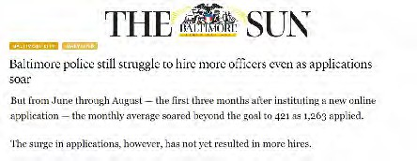

**Redeploy.** In light of current police shortages, we must seek to redeploy police officers and get short-term assistance from partner agencies. As Mayor, Thiru would pursue several strategies:

* + Redeploy school police to assist with patrol in neighborhoods around assigned schools.

Baltimore is the sole jurisdiction in Maryland with a sworn school police force. While the debate about the advantages and drawbacks of school police continues, there is little question these 90 well-trained officers could perform a valuable patrol function in the neighborhoods around their schools. School officers are permitted to carry firearms when they patrol outside of the facility but must store them in a secure location during school hours. Put simply, right now, we need more teachers and social workers inside schools and more police on the streets. That’s where Thiru, as Mayor, would redeploy them.

* + Reestablish role of Sheriff’s Office in warrant apprehension and community policing.

The “End the Bloodshed” plan requires every available detective to work violent crime investigations. Increasing patrol at the expense of detective work in the name of community policing is a short-sighted strategy. But, to be sure, community policing is vital to Baltimore City. This is a role that the Sheriff’s Office is perfect to play. Dozens of Baltimore sheriffs could assist with community policing, building relationships in the neighborhoods and assisting with local events. This would reinforce the strong reputation sheriffs enjoy in the community and would free up detectives from working mandatory overtime patrol shifts while carjacking, shooting, and murder investigations languish.

* + Accelerate civilianization of the police force.

BPD has begun to recruit more civilian personnel but has yet to move sworn officers out of civilian roles and back onto the streets where they are most needed. Within 100 days, the Department will identify all sworn officers working in positions where civilian employees would be appropriate. Within six months, those officers would be assigned to patrol and detective units, allowing incoming civilian personnel to backfill those spots.

* + Utilize private police to reduce costs for business district and special event deployments.

Veteran detectives who have been reassigned to address patrol deficits need to return to detective work. Patrol shortages can be mitigated by relying, in the short term, on private police who can handle shifts that are currently exacerbating overtime expenditures.

**Retrain.** Building a police force for the next generation of BPD is not just about hiring new and younger officers. It also requires the Department to better train officers to police a diverse urban population with soaring crime and unprecedented mistrust in police.

As Mayor, Thiru will require BPD to develop and institute cutting-edge training modules for cadets and in-service training for veteran officers to better prepare them with respect to de-escalation strategies, crisis response, trauma and mental health, implicit bias, youth-interaction, best practices for body-worn cameras, community policing, and more. Preparing officers for next-generation policing will also require next-generation teaching methods. For implicit bias, for example, Prince George’s County began using virtual reality tools in 2018, tools that Researchers at the University of Maryland found to be a low-cost option for health care professionals, engineers, and technicians. Existing training also needs to be updated with new insights. For instance, police will need to be trained to change the presumption from “off” to “on” for body-worn cameras, so that citizens do not interpret activation of body cameras as an escalation in the encounter.

**Break the Cycle of Poverty, Crime, and Prison**

To end the bloodshed in Baltimore, we must break the pernicious cycle of poverty, crime, and prison. An estimated 73% of those individuals released from prison who return to Baltimore City are rearrested and reincarcerated within three years. This is a literal revolving door. As Mayor, Thiru would break this pattern at four separate points.

* + For the 80-100 most at-risk individuals scheduled for release to Baltimore City each month, develop a customized reentry plan for those returning citizens a full year in advance.

Preparing for successful reentry cannot begin upon a person’s return to society. It has to start much earlier. City Hall cannot assume this responsibility for all individuals returning from prison. But, for those at greatest risk of being killed or killing someone else, the Deputy Mayor for Public Safety will work with DPSCS to ensure that a comprehensive reentry strategy is in place one year before the inmate’s scheduled release. This plan will address skills deficits, trauma and addiction, and housing challenges; it will develop a plan for where the inmate will live, work, and sleep, to whom that person will report, and on whom that person can rely for support. It will impose strict conditions of release so that their progress can be monitored and assessed. The aspiration cannot be to expect everyone to turn their lives around immediately, but to reverse expectations so that instead of three out of four returning to prison, more than 75% move in the direction of a constructive, sustainable life.

* + Remove structural impediments that prevent and discourage returning citizens from pursuing gainful, legal employment.

For many returning citizens, unpaid child support debt—debt owed to the government that has already been paid to the spouse primarily responsible for the child—carries consequences that make lawful employment highly unappealing. A returning citizen’s driver’s license can be suspended, and two-thirds of a person’s reported income is garnished to service the unpaid debt. Under the current system, less than 2% of the overall debt is ever collected. Yet we maintain these draconian consequences, which only makes it more likely that a person returning from prison will return to illegal activities to

make money rather than take a job that, on paper, pays $12 an hour but, in reality, yields $4 an hour.

As Mayor, Thiru will establish smarter, more rational incentives, guaranteeing that one quarter of the debt is forgiven or repaid by the City after a returning citizen has maintained stable employment and stayed out of trouble for six months, one half at one year and the full amount at two years. The City would also work with the relevant state agencies to end the practice of suspending driver’s licenses as a method of encouraging repayment of debt. It is counterproductive and wrong.

* + Launch the “Faith in Justice” reentry initiative to match returning citizens with 100 nonprofits and faith organizations who will each support five individuals returning to Baltimore.

Federal laws like the Second Chance Act provide for federal grant money for reentry initiatives. As Mayor, Thiru will launch the “Faith in Justice” reentry initiative, securing $5,000,000 in federal grant money from the Second Chance Act, which will be dispersed to 100 nonprofits and faith organizations selected individually by 500 returning citizens to support their return to Baltimore. Because the nonprofit or faith organization is chosen by the returning citizen, there is no constitutional impediment to government money being provided to tax exempt religious institutions. At the same time, this would provide about

$10,000 per returning citizen for the church or synagogue or nonprofit to allocate, in coordination with the individual, to best support his or her success. Participating organizations would be expected to maintain scrupulous records and assessments would be made annually, evaluating concrete metrics such as reported taxable income and the number of months of safe and stable housing.

* + Establish the “Court to Career” adult diversion program and a parallel “School to Success” program for diverting juvenile offenders.

As Mayor, Thiru will ensure that City Hall takes responsibility for working with the courts to identify appropriate adult and juvenile candidates and establish partnerships with apprenticeship programs, workforce development initiatives, and welcoming business partners who together will provide a reliable pipeline for qualifying juveniles and individuals charged with low-level offenses to enter workforce development and job placement programs as a condition of their probation.

This initiative will ultimately divert 10,000 individuals each year from the revolving door of poverty, crime, and prison to a constructive path of skills training and job placement. Each year we charge tens of thousands in Baltimore with offenses ranging from drug possession to simple assault. To end the bloodshed, we have to bring to bear the resources we have and concentrate them on violent crime. Low-level offenses cannot be altogether ignored, but diverting thousands of these individuals and their cases to a more constructive path than incarceration will free up much-needed resources that are essential to combat and curb violence in Baltimore.

Between the “Court to Career” program (C2C) and the “School to Success” pipeline (S2S), Baltimore will pioneer a new approach to diversion, using interactions with the criminal justice system as an opportunity to divert juveniles at risk of entering the school to prison pipeline and adults at risk of incarceration for low-level offenses to workforce development and employment opportunities. Key features of these initiatives will be:

* Offering petty, non-violent offenders a permanent extinguishment of charges in exchange for the completion of an apprenticeship program that provides skills and training followed by specific job placement
* Offering qualifying juvenile offenders an opportunity to avoid a finding of delinquency if the individual, as a condition of a probationary period, pursues an apprenticeship and commences a paid employment opportunity of their choice
* Securing $10 million in funding through public-private partnership, to expand the existing “District Court Reentry Project” and ensure that there is a sufficient number of case workers, with a dozen being hired during the initiative’s first year
* Extending employment alternatives by partnering with Baltimore employers who are committed to hiring ex-offenders that have devoted apprenticeship programs and opportunities for future employment

These public-private partnerships will invest $10+ million to expand and bring to scale the Baltimore City District Court Re-Entry Project (DCREP), a model program that currently receives virtually no support from City Hall or the City

Council. That program, which long operated with only one full-time employee, is supported by judges and volunteers and has a recidivism rate of less than 6% — a far cry from the 73% of returning citizens in Baltimore City who are rearrested and reincarcerated within three years of leaving prison. More can be done, more efficiently.

In its first full year, C2C and S2S will help divert 1,000 individuals who are charged with low-level offenses first to job training and then to paid employment opportunities as a condition of receiving a probation before judgment (PBJ). This will require partnerships between district court judges and juvenile masters, probation officers, case workers, skills training programs, apprenticeships, and employers who are prepared to hire at-risk individuals and give them a second chance. Only when individuals complete the program, having demonstrated stable employment and no criminal activity, are they taken off probation with their records expunged. For juveniles, the programs will adopt apprenticeships and work schedules that are compatible with school and other vital obligations.

**“Every election, candidates talk about tearing down prisons and creating opportunity. After the election, nothing gets done. Nothing changes. Baltimore needs more than soundbites, spin, and slogans, more than ribbon-cuttings and press conferences. We need real investment in concrete programs that work.”**

**Assemble Stronger Cases for City Prosecution**

CLEAR THE FORENSIC BACKLOG

Law enforcement in Baltimore has to build stronger cases. City prosecutors are dropping too many prosecutions, pleading out felonies to unjustifiably lenient sentences, and losing over 80% of cases that go to trial. To help prosecutors succeed, particularly inexperienced ones, police officers must build stronger cases that will withstand the scrutiny of judges and juries.

Unexamined forensic evidence presents one opportunity to strengthen cases. Baltimore has a massive backlog of untested rape kits and burglary crime scene evidence. As of 2022, the city had 991 untested rape kits. The current practice of not testing burglary crime scene evidence is also an enormous missed opportunity, since 40% of DNA and fingerprints from burglary crime scenes match a profile in the federal CODIS database.

Clearing these backlogs should be a priority. Current legislation already mandates that rape kits be tested in “a timely manner," but forensic labs are often so inundated with evidence that they lack the capacity to test within a reasonable time frame. As Mayor, Thiru will secure and allocate resources to ensure the timely testing of rape kit and burglary crime scene evidence as part of the larger push to identify repeat and violent criminals.

Testing the backlog of burglary crime evidence, given the high yield rate, would permit police and prosecutors to distinguish between, on the one hand, low-level offenders whose conduct is in the past and, on the other hand, repeat violent offenders who may be readily prosecuted for a burglary even if there is insufficient evidence to expect a shooting or murder prosecution.

EXPAND THE GROUND AND AERIAL CAMERA NETWORK

In a city without the resources to consistently patrol every block and street corner, it is hard to protect homes and businesses from criminal activity. A rampant illegal drug trade and soaring gun violence have contributed to Baltimore’s spot on America’s most violent cities list. As a result, Baltimore’s understaffed police department has

trouble devoting the requisite person-power to finding perpetrators of muggings, robberies, and fatal assaults.

Baltimore’s storeowners and landlords often keep surveillance cameras on their properties in order to help identify offenders, but these cameras have minimal storage and are not easily accessible.

As Mayor, Thiru will provide $100 rebates for all businesses and residences to install up-to-date, networked security cameras and to register them with BPD. In the event of a crime, police can request footage from the camera owners who can consent or decline. Some are already using home camera networks and working with police to solve crime in their neighborhoods.

In addition, Thiru has pledged to re-launch the aerial surveillance program, this time after public input and with specific restrictions to ensure its legality. While the last effort in 2016 to use the technology in was indefensible and likely unconstitutional, aerial surveillance is ultimately a potent tool to solve violent crimes. Investigators can follow captured pixels tied to a crime to determine where the subject came from and went. When the pixel passes a street camera at a particular time, police have an opportunity to get a closer look. The tandem of aerial footage that traces the path of “dots of interest” coupled with a sprawling network of higher-resolution, ground cameras could significantly improve clearance and conviction rates.

**Thiru has called for several restrictions before launch:**

* Aerial surveillance footage would be available to the police only to help with certain violent crime investigations involving homicides, shootings, and carjackings.
* Except in emergencies (*e.g.*, an active shooter scenario), police would need to get a warrant signed by a judge supported by probable cause in order to obtain the footage.
* Every three to six months, the city would publish a list of the cases in which surveillance was obtained and indicate whether that crime was solved.
* To help defend their clients, attorneys would be entitled to subpoena footage that could be used to undermine a witness’s testimony, challenge a statement of probable cause in a search warrant affidavit, and more broadly hold officers accountable.
* The program would be overseen by a five-member civilian oversight board, composed of city residents selected by the mayor and other community stakeholders.
* Aerial view footage and all related data would be archived for a fixed period but could never be shared with or sold to anyone, public or private, and could not be accessed by the operator or anyone else without a court order.

**“Unparalleled violence demands unparalleled ingenuity, and we must leave reasonable options on the table as we prevent, solve, and deter hundreds of murders each year.”**

**Strengthening Partnerships and Policing**

Baltimore also needs to build a better network of relationships with its law enforcement partners at local, state, and federal levels, state agencies involved in juvenile justice, re-entry, parole and probation, and the broader Baltimore community.

Under the *End the Bloodshed* plan Thiru will seek the following objectives:

* + For the first time, Baltimore will **refer to the U.S. Attorney’s Office for automatic review** all carjackings, bank and commercial robberies, and felon-in- possession cases for potential federal prosecution. (These are categories of crimes over which there is federal jurisdiction.)
  + For the first time, Baltimore will facilitate **anonymized monitoring of juvenile cases**, so the public can better track outcomes in violent crime cases involving juvenile offenders.
  + For the first time, Baltimore will prepare a **non-public list of repeat violent juvenile offenders** and develop customized strategies to ensure they are brought to justice.
  + For the first time, Baltimore will **create a Deputy Mayor for Public Safety** who will ensure interagency cooperation to support BPD fully in the fight against crime, a post that will be filled by a respected crime fighter.
  + For the first time, Baltimore will **form the Office of the Public Advocate**, which will ensure that policing satisfies community expectations and constitutional standards, a post that will be filled by a respected community activist and civil rights leader.
  + For the first time, Baltimore will deter police corruption by **instituting automatic audits of overtime** where an officer has claimed more than $10,000 in overtime compensation.
  + For the first time, Baltimore will publish an **annual report of public health indicators that drive violence** to ensure that the work of all agencies is evaluated in the fight against crime.
  + For the first time, Baltimore will once a month **open ComStat to press and the public** in order to promote police accountability and greater transparency.

**A FINAL NOTE**

The Thiru for Baltimore Team hopes that this initial plan can be understood as a call to initiate both the “sprints” necessary in the short-term to drastically reduce crime, as well as the first few miles of a much longer marathon to break the cycles of poverty, inequity, and injustice that keep too many Baltimoreans from achieving the success and prosperity that they deserve.

We also hope this document fuels serious discussion about the standards we accept – for our elected officials, our police department and its officers, as well as ourselves when it comes to confronting and tackling the issues that have plagued the narratives about and the realities within our city for decades.

We welcome your thoughts and ideas at [outreach@thiru2024.com,](mailto:outreach@thiru2024.com,) for after all…

***We cannot unleash the promise of Baltimore until we address violent crime. But we can, and we will – together.***

